
DECRIPTION ON EXAUST FANS | WRITTEN BY:DEHYA KHURRAIM SIDDQUI & SAFDER REHMAN
FANoFAN | PADASTRAL FANS

Table of Contents

TURBO 180 ------------------------------------------------------3
FARRATTA ------------------------------------------------------5
FARRATTA EX ------------------------------------------------------7
MIST AIR ICY ------------------------------------------------------9
JET DLX ------------------------------------------------------11
CHEETAH DLX ------------------------------------------------------13
HELIX PRO HI-SPEED ------------------------------------------------------15
HELIX MEGA ------------------------------------------------------17

Figures
Figure 1 3
Figure 2 5
Figure 3 7
Figure 4 9
Figure 5 11
Figure 6 13
Figure 7 15
Figure 8 19

TURBO 180

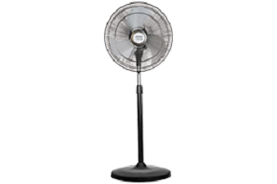
Figure 1
COLOUR: BLACK SPEED: 1330 RPM
SWEEP: 450 mm Power Input: 120 W Air Delivery: 125 M³/Min PRICE: RS 4950

KEY FEATURE:

RPM 1330 125 m³/h 450 MM

FARRATTA

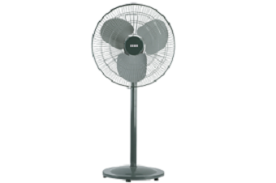
Figure 2
COLOUR: GREY SPEED: 1350 RPM
SWEEP: 500 mm Power Input: 160 W
Air Delivery: 90 M³/Min PRICE: RS 4460

KEY FEATURE:
RPM 1350 90 m³/h 500MM

FARRATTA EX

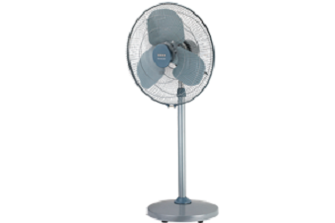
Figure 3
COLOUR: GREY SPEED: 1350 RPM
SWEEP: 500 mm Power Input: 160 W
Air Delivery: 90 M³/Min PRICE: RS 4300

KEY FEATURE:
RPM 1350 90 m³/h 500MM

MIST AIR ICY

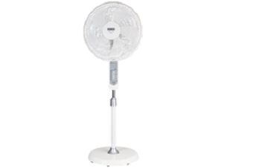
Figure 4
COLOUR: WHITE SPEED: 1180 RPM
SWEEP: 400 mm Power Input: 50 W
Air Delivery: 67 M³/Min PRICE: RS 3960

KEY FEATURE:
RPM 1180 67 m³/h 400MM

JET DLX

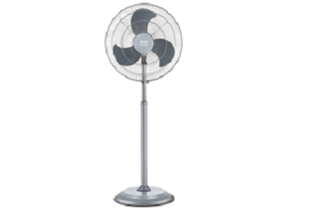
Figure 5
COLOUR: STEEL GREY SPEED: 1400 RPM
SWEEP: 450mm Power Input: 110
Air Delivery: 90 M³/Min PRICE: RS 3690

KEY FEATURE:
RPM 1400 90 m³/h 450MM

CHEETAH DLX

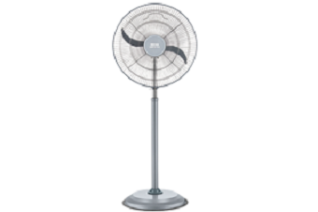
Figure 6
COLOUR: GREY SPEED: 2600 RPM
SWEEP: 450mm Power Input: 130 W
Air Delivery: 90M³/Min PRICE: RS 3490

KEY FEATURE:
RPM 2600 90 m³/h 450MM

HELIX PRO HI-SPEED

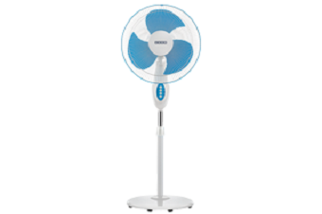
Figure 7
COLOUR: BLUE SPEED: 2300 RPM
SWEEP: 400 mm Power Input: 120 W
Air Delivery: 98 M³/Min PRICE: RS 3470

KEY FEATURE:
RPM 2300 98 m³/h 400MM

HELIX MEGA

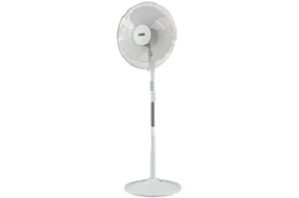
Figure 8
COLOUR: WHITE SPEED: 2200 RPM
SWEEP: 400 mm Power Input: 115 W
Air Delivery: 100 M³/Min PRICE: RS 3470

KEY FEATURE:
RPM 2200 100 m³/h 400MM

WRITTEN BY

DEHYA KHURRAIM SIDDQUI : WEB DESIGNER
SAFDER REHMAN : WEB EDITOR

IN SUPPERVISION OF

MISS ALMAS.

WEBSITE LINK

